Doom Eternal
Experience the ultimate gaming journey!
——————————————————————————————————————

🎮 Game Information
Developer | id Software
Publisher | Bethesda Softworks
Release Date | 20 Mar, 2020
Genre | Action
Platforms | PC

📝 Description

Hell’s armies have invaded Earth. Become the Slayer in an epic single-player campaign to conquer demons across dimensions and stop the final destruction of humanity.

✨ Key Features
• Story Rich
• Multiplayer Mode
• Great Soundtrack

📸 Screenshots
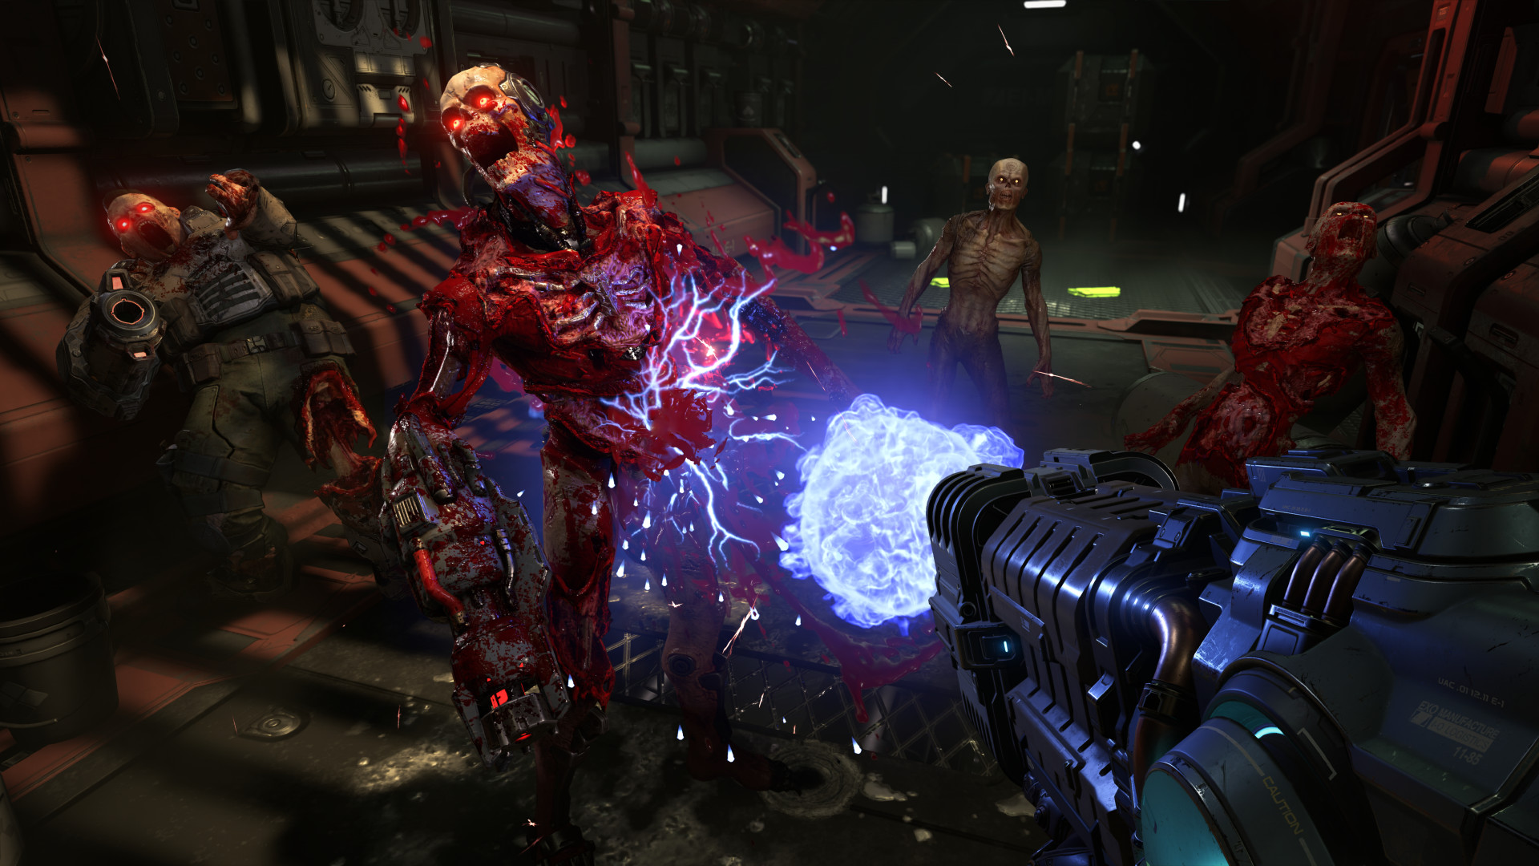

💻 System Requirements
Minimum Requirements | Recommended Requirements
Processor: Intel Core i5 @ 3.3 GHz or better, or AMD Ryzen 3 @ 3.1 GHz or better | Processor: Intel Core i7-6700K or better, or AMD Ryzen 7 1800X or better
RAM: 8 GB RAM | RAM: 8 GB RAM
Graphics: NVIDIA GeForce GTX 1050Ti (4GB), GTX 1060 (3GB), GTX 1650 (4GB) or AMD Radeon R9 280(3GB), AMD Radeon R9 290 (4GB), RX 470 (4GB | Graphics: NVIDIA GeForce GTX 1060 (6GB), NVIDIA GeForce 970 (4GB), AMD RX 480 (8GB)
Storage: 80 GB available space | Storage: 80 GB available space

