Forza Horizon 5
Experience the ultimate gaming journey!
——————————————————————————————————————

🎮 Game Information
Developer | Playground Games
Publisher | Xbox Game Studios
Release Date | 9 Nov, 2021
Genre | Action, Adventure, Racing, Simulation, Sports
Platforms | Xbox

📝 Description
Your Ultimate Horizon Adventure awaits! Explore the vibrant and ever-evolving open world landscapes of Mexico with limitless, fun driving action in hundreds of the world’s greatest cars.

✨ Key Features
• Open World Exploration
• Multiplayer Mode
• Stunning Graphics

📸 Screenshots
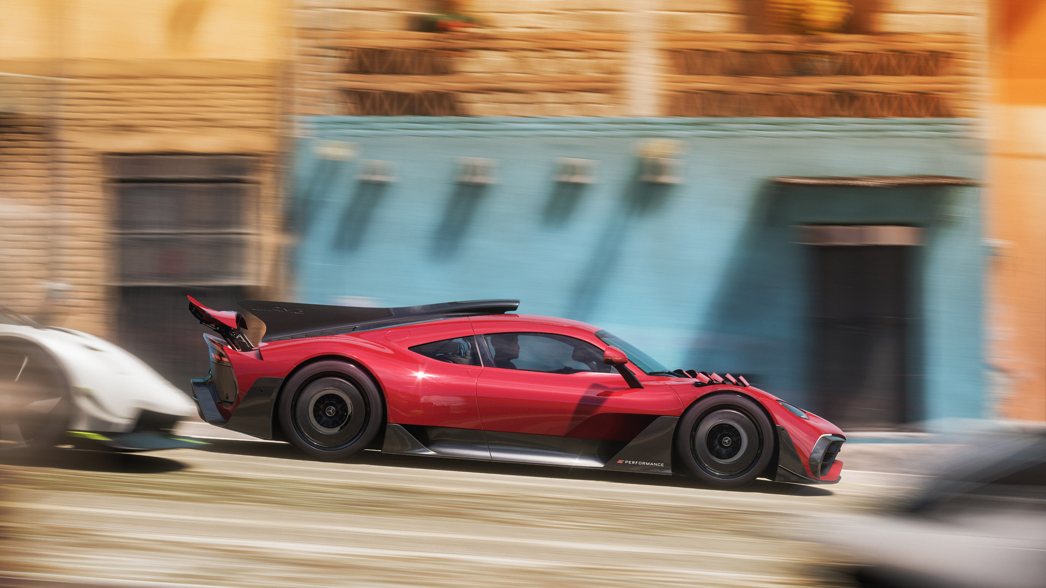

💻 System Requirements
Minimum Requirements | Recommended Requirements
Processor: Intel i5-4460 or AMD Ryzen 3 1200 | Processor: Intel i5-8400 or AMD Ryzen 5 1500X
RAM: 8 GB RAM | RAM: 16 GB RAM
Graphics: NVidia GTX 970, AMD RX 470, OR Intel Arc A380 | Graphics: NVidia GTX 1070, AMD RX 590, OR Intel Arc A750
Storage: 110 GB available space | Storage: 110 GB available space

