GOD Of War RAGNAROK
Experience the ultimate gaming journey!
———————————————————————————————————————

🎮 Game Information
Developer | Game Science
Publisher | Game Science
Release Date | 20 Aug, 2024
Genre | Action, Adventure, RPG
Platform | PC

📝 Description

Black Myth: Wukong is an action RPG rooted in Chinese mythology. The story is based on Journey to the West, one of the Four Great Classical Novels of Chinese literature. You shall set out as the Destined One to venture into the challenges and marvels ahead, to uncover the obscured truth beneath the veil of a glorious legend from the past

✨ Key Features
• Action RPG
• Dark Fantasy
• Stunning Graphics

📸 Screenshots
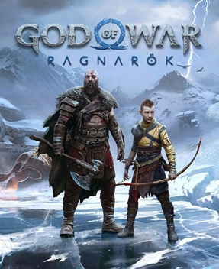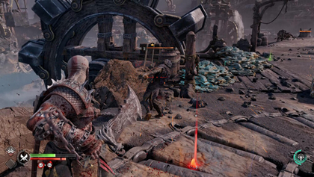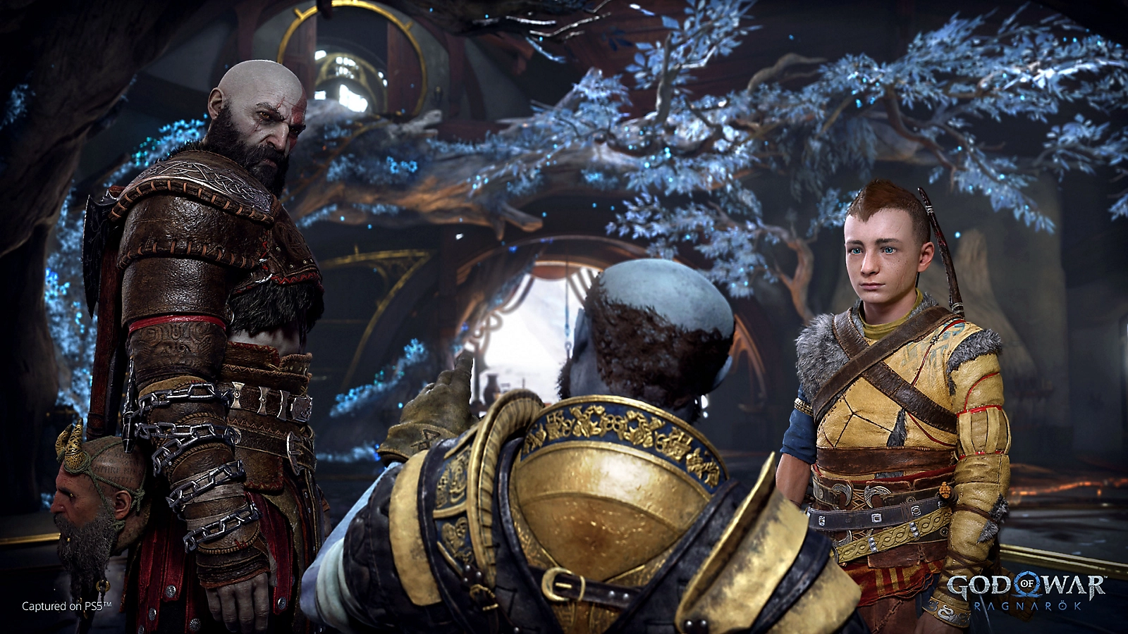

💻 System Requirements
Minimum Requirements | Recommended Requirements
Processor: Intel Core i5-8400 / AMD Ryzen 5 1600 | Processor: Intel Core i7-9700 / AMD Ryzen 5 5500
RAM: 16 GB RAM | RAM: 16 GB RAM
Graphics: NVIDIA GeForce GTX 1060 6GB / AMD | Graphics: NVIDIA GeForce RTX 2060 / AMD Radeon
Storage: 130 GB available space | Storage: 130 GB available space

