Gears 5
Experience the ultimate gaming journey!
——————————————————————————————————————

🎮 Game Information
Developer | The Coalition
Publisher | Xbox Game Studios
Release Date | 10 Sep, 2019
Genre | Action, Adventure
Platforms | Xbox, PC

📝 Description
From one of gaming’s most acclaimed sagas, Gears is bigger than ever. With all-out war descending, Kait Diaz breaks away to uncover her connection to the enemy and discovers the true danger to Sera – herself.

✨ Key Features
• Action-Adventure
• Multiplayer Mode
• Female Protagonist

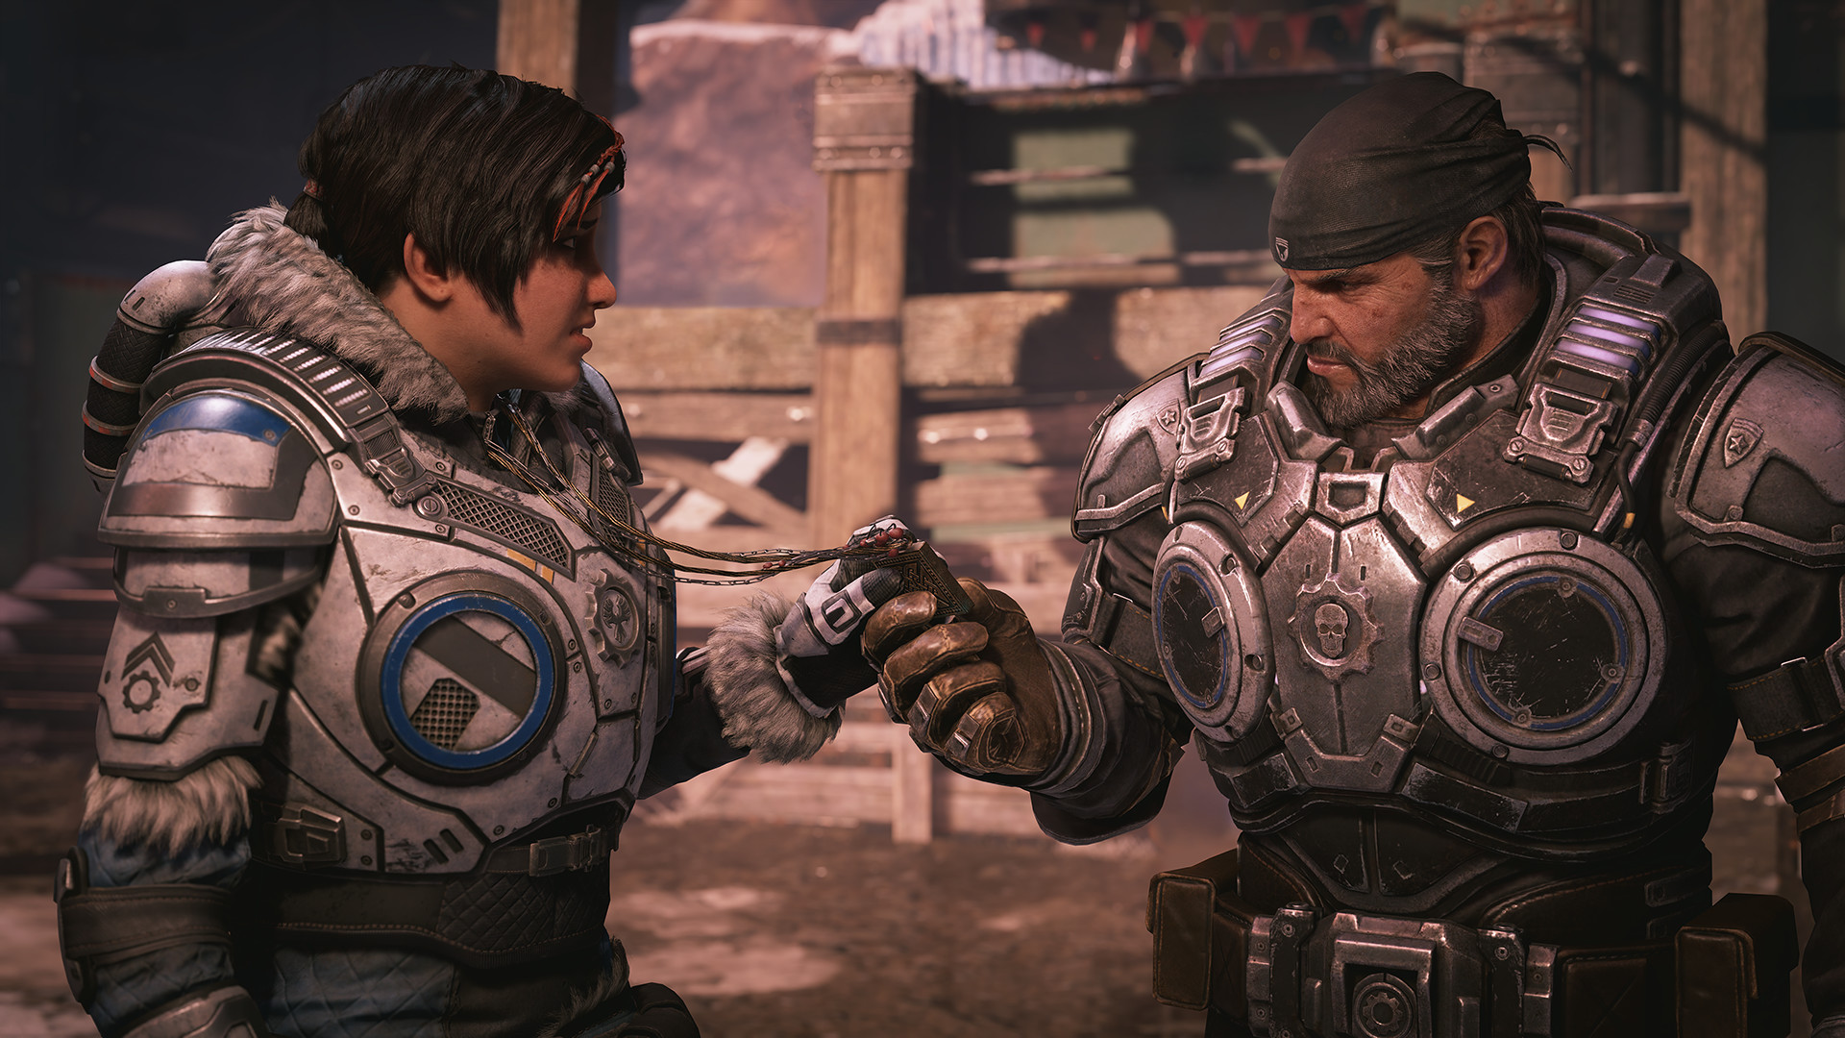
📸 Screenshots
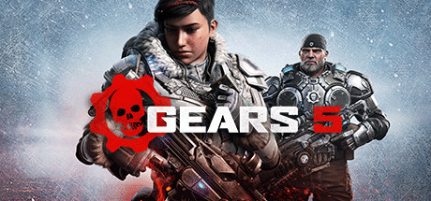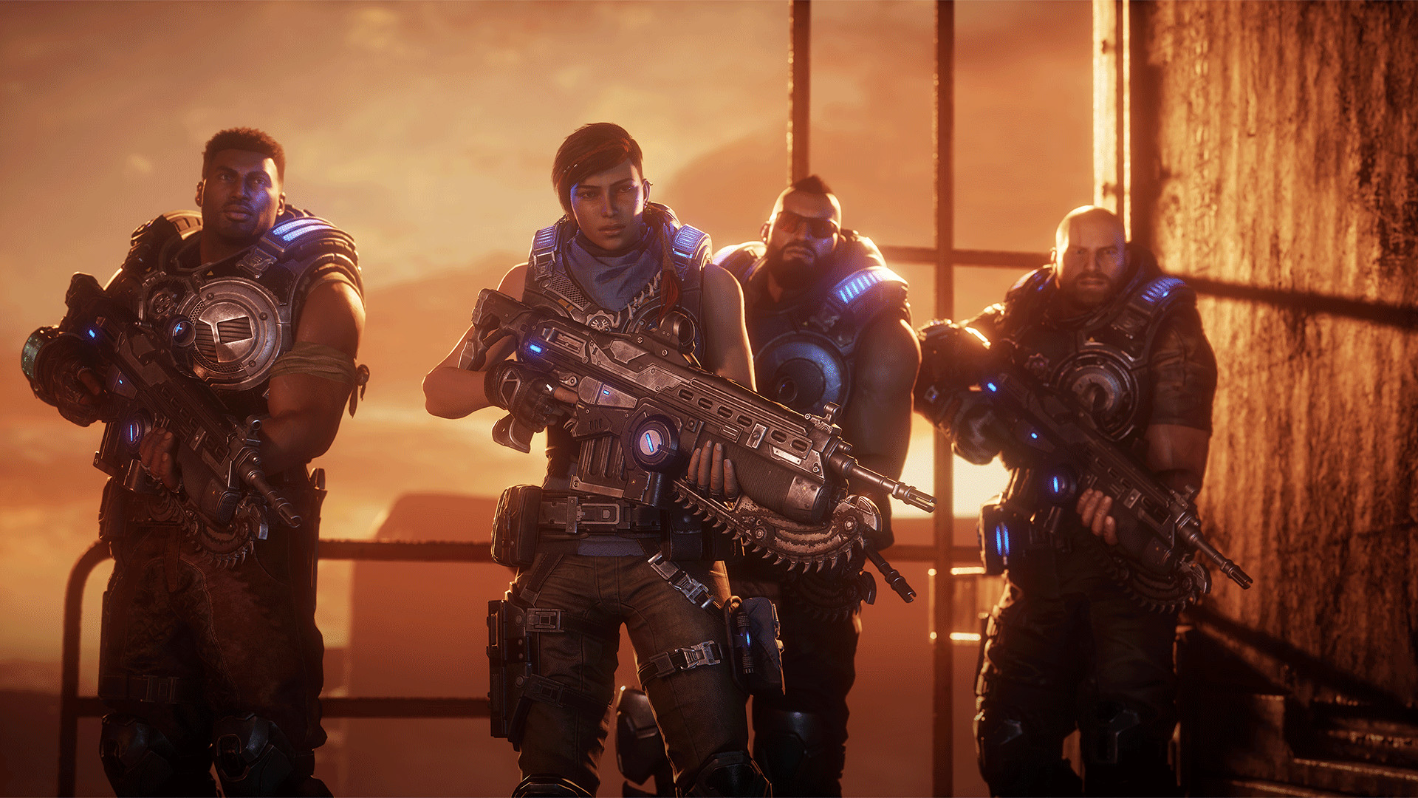

💻 System Requirements
Minimum Requirements | Recommended Requirements
Processor: AMD FX-6000 series | Intel i3 Skylake | Processor: AMD Ryzen 3 | Intel i5 Skylake
RAM: 8 GB RAM | RAM: 8 GB RAM
Graphics: AMD Radeon R9 280 | NVIDIA GeForce GTX 760 (Windows 10) | NVIDIA GeForce GTX 1050 (Windows 7) | Graphics: AMD Radeon RX 570 | NVIDIA GeForce GTX 970 (Windows 10) | NVIDIA GeForce GTX 1660ti (Windows 7)
Storage: 80 GB available space | Storage: 80 GB available space

