Horizon Forbidden West
Experience the ultimate gaming journey!
——————————————————————————————————————

🎮 Game Information
Developer | Guerrilla, Nixxes Software
Publisher | PlayStation Publishing LLC
Release Date | 21 Mar, 2024
Genre | Action, RPG
Platforms | PS5, PC

📝 Description
Experience the epic Horizon Forbidden West™ in its entirety with bonus content and the Burning Shores expansion included.

✨ Key Features
• Open World Exploration
• Singleplayer
• Stunning Graphics

📸 Screenshots
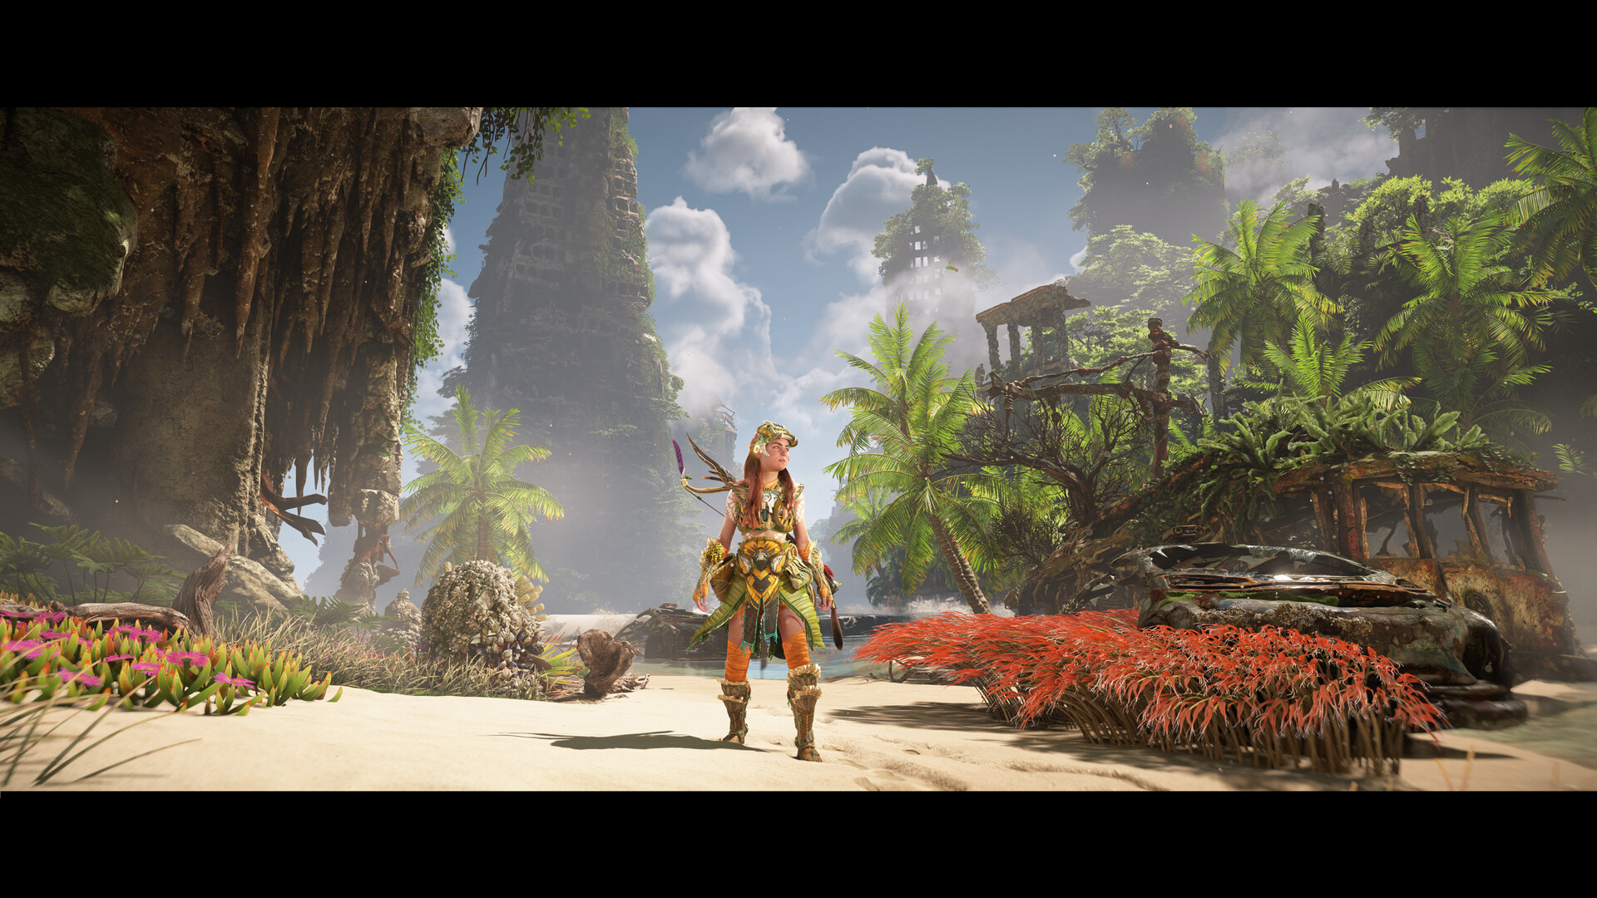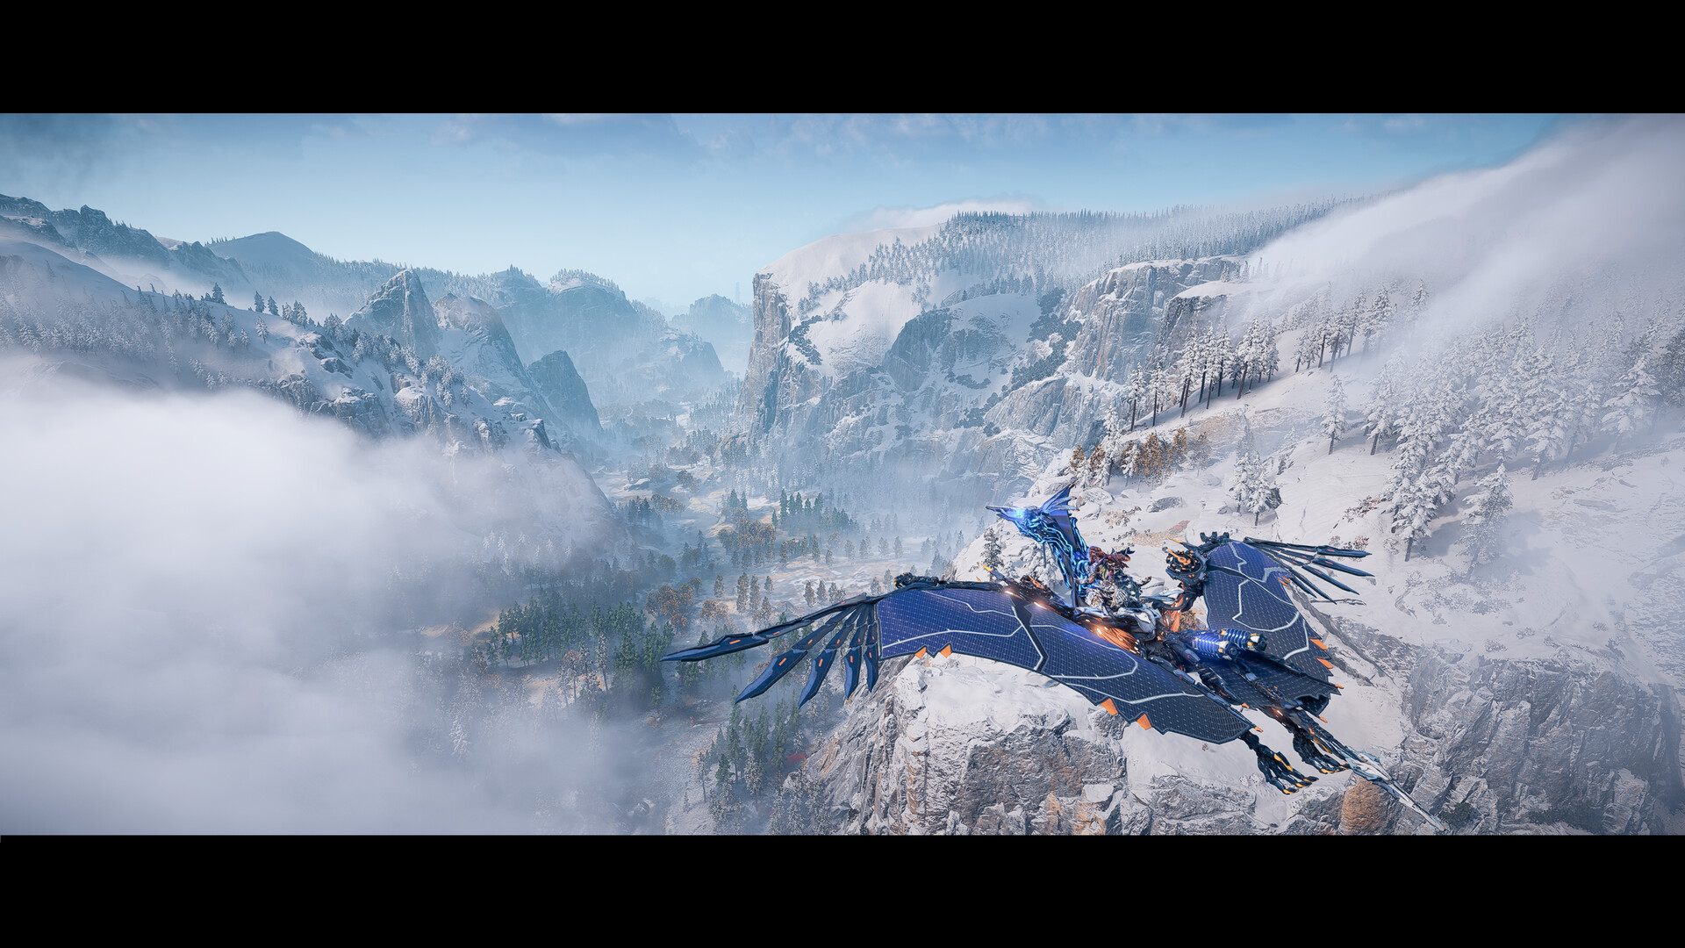

💻 System Requirements
Minimum Requirements | Recommended Requirements
Processor: Intel Core i3-8100 or AMD Ryzen 3 1300X | Processor: Intel Core i5-8600 or AMD Ryzen 5 3600
RAM: 16 GB RAM | RAM: 16 GB RAM
Graphics: NVIDIA GeForce GTX 1650 4GB or AMD Radeon RX 5500XT 4GB | Graphics: NVIDIA GeForce RTX 3060 or AMD Radeon RX 5700
Storage: 150 GB available space | Storage: 150 GB available space

