Mario Kart 8 Deluxe
Experience the ultimate gaming journey!
——————————————————————————————————————

🎮 Game Information
Developer | Nintendo
Publisher | Nintendo
Release Date | March 16, 2020
Genre | Kart Racing
Platforms | Nintendo Switch

📝 Description
Mario Kart 8 is a kart racing game; players control characters from the Mario universe, The Legend of Zelda, Animal Crossing, Splatoon,^{[e]} or the players' Miis, to race in go-karts around a course .

✨ Key Features
• Kart Racing
• Multiplayer Mode
• Best Selling

📸 Screenshots
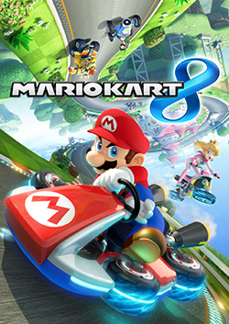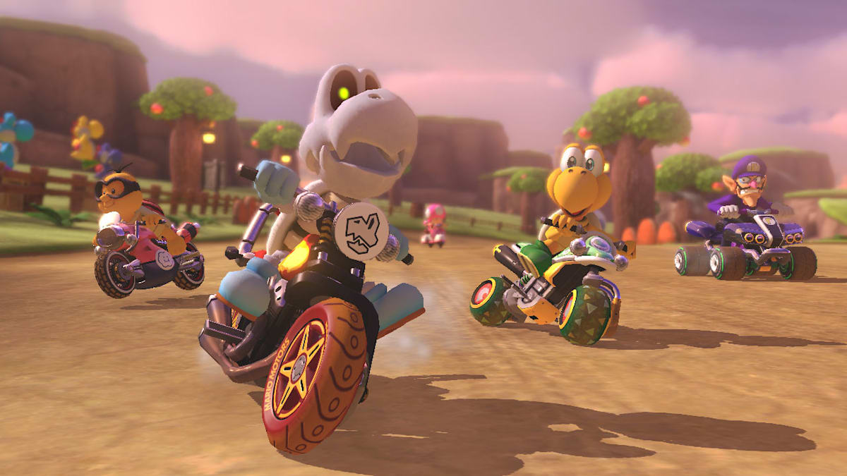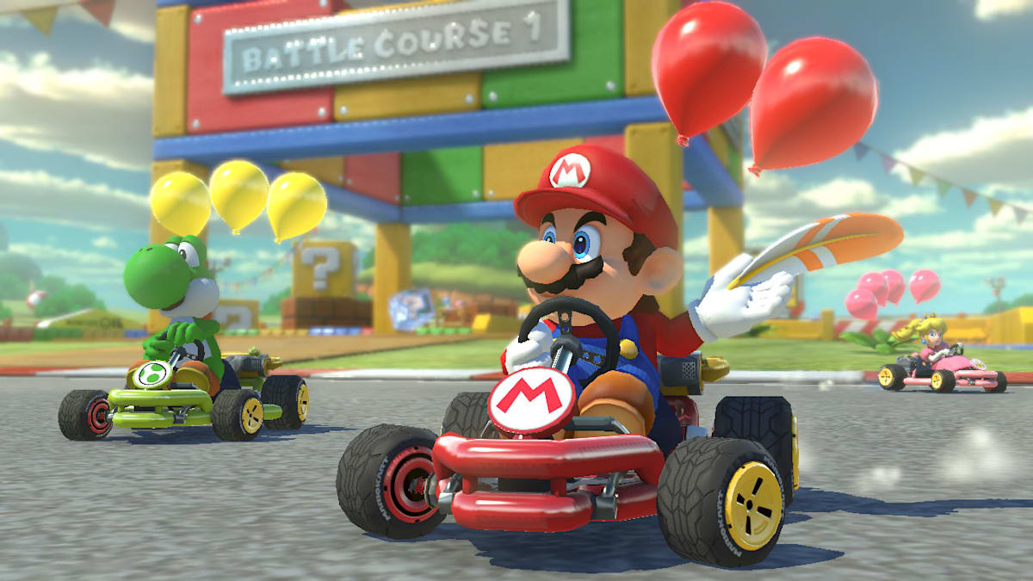

💻 System Requirements
Minimum Requirements | Recommended Requirements
Device: Nintendo switch | Device: Nintendo Switch
Storage: 11.3 GB | Storage: 11.3 GB

