Ratchet & Clank: Rift Apart
Experience the ultimate gaming journey!
——————————————————————————————————————

🎮 Game Information
Developer | Insomniac Games, Nixxes Software
Publisher | PlayStation Publishing LLC
Release Date | 26 Jul, 2023
Genre | Action Role-Play
Platforms | PlayStation 5

📝 Description
Blast your way through an interdimensional adventure with Ratchet and Clank – now on PC! Help them take on an evil emperor from another reality as you jump between action-packed worlds and beyond at hyper-speed!

✨ Key Features
• 3D Platformer
• Action-Adventure
• Stunning Graphics

📸 Screenshots
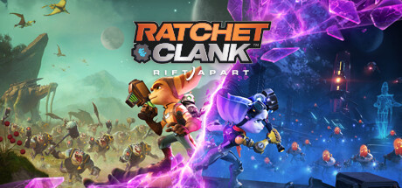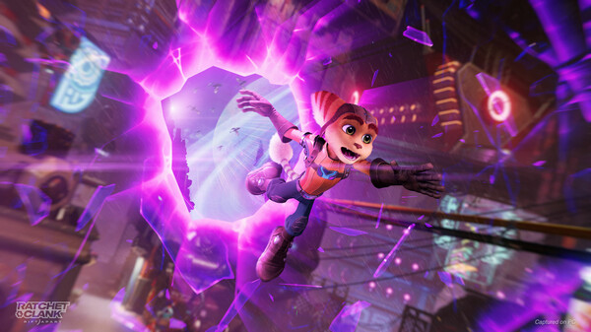

💻 System Requirements
Minimum Requirements | Recommended Requirements
Processor: PlayStation 5 console | Processor: PlayStation 5 console
Graphics: 60 FPS with dynamic 4K resolution | Graphics: 60 FPS with dynamic 4K resolution
Storage: 75 GB available space | Storage: 75 GB available space

