Super Mario Odyssey
Experience the ultimate gaming journey!
——————————————————————————————————————

🎮 Game Information
Developer | Nintendo
Publisher | Nintendo
Release Date | October 27, 2017
Genre | Platformer, Action
Platforms | Nintendo switch

📝 Description
Super Mario Odyssey is a platform game in which players control Mario as he travels across 14 different worlds, known as "Kingdoms" within the game, on the hat-shaped ship Odyssey, to rescue Princess Peach from Bowser, who plans to forcibly marry her

✨ Key Features
• Open World Exploration
• Action
• Adventure

📸 Screenshots
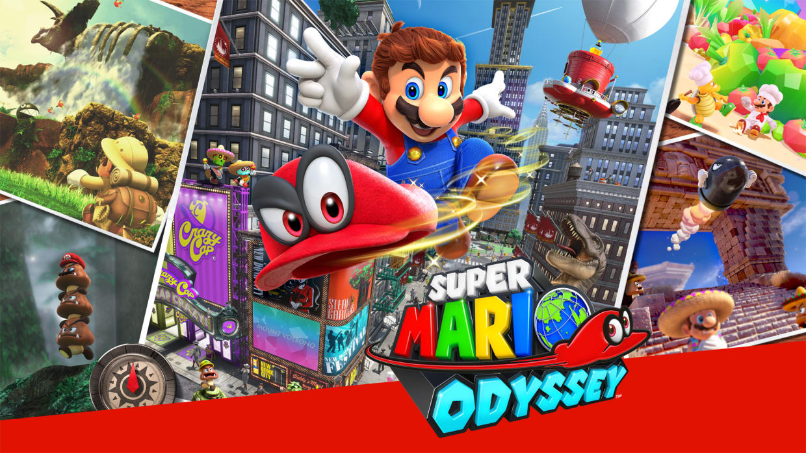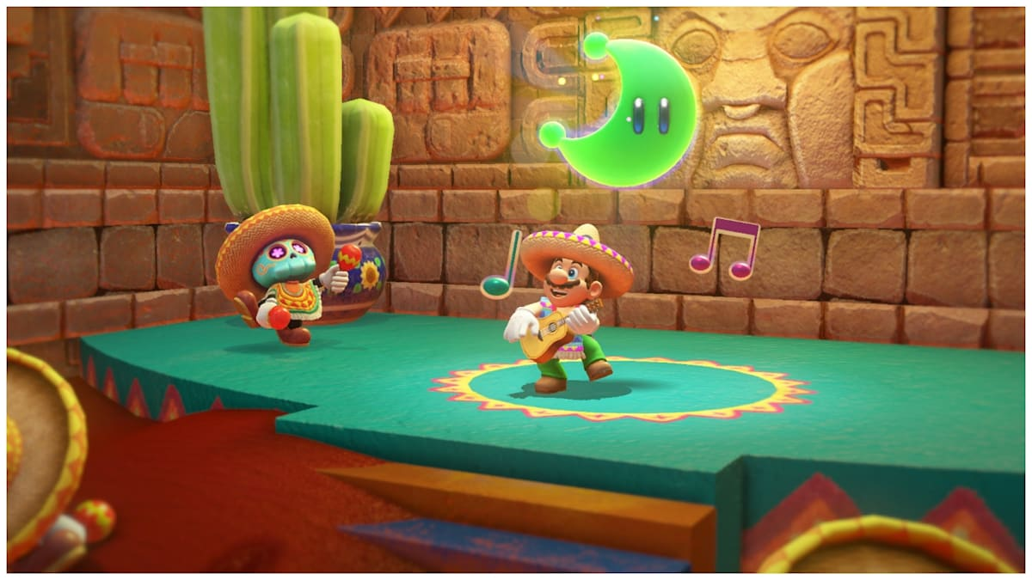

💻 System Requirements
Minimum Requirements | Recommended Requirements
Device: Nintendo Switch | Device: Nintendo Switch
Storage: 5.6 GB | Storage: 5.6 GB

