Super Smash Bros. Ultimate
Experience the ultimate gaming journey!
——————————————————————————————————————

🎮 Game Information
Developer | Nintendo
Publisher | Nintendo
Release Date | December 7, 2018
Genre | Action, Fighting, Multiplayer
Platforms | Nintendo Switch

📝 Description
Super Smash Bros. Ultimate is a platform fighter for up to eight players in which characters from Nintendo games and third-party franchises fight to knock each other out of an arena.

✨ Key Features
• Campaign
• Multiplayer Mode
• Fighting

📸 Screenshots
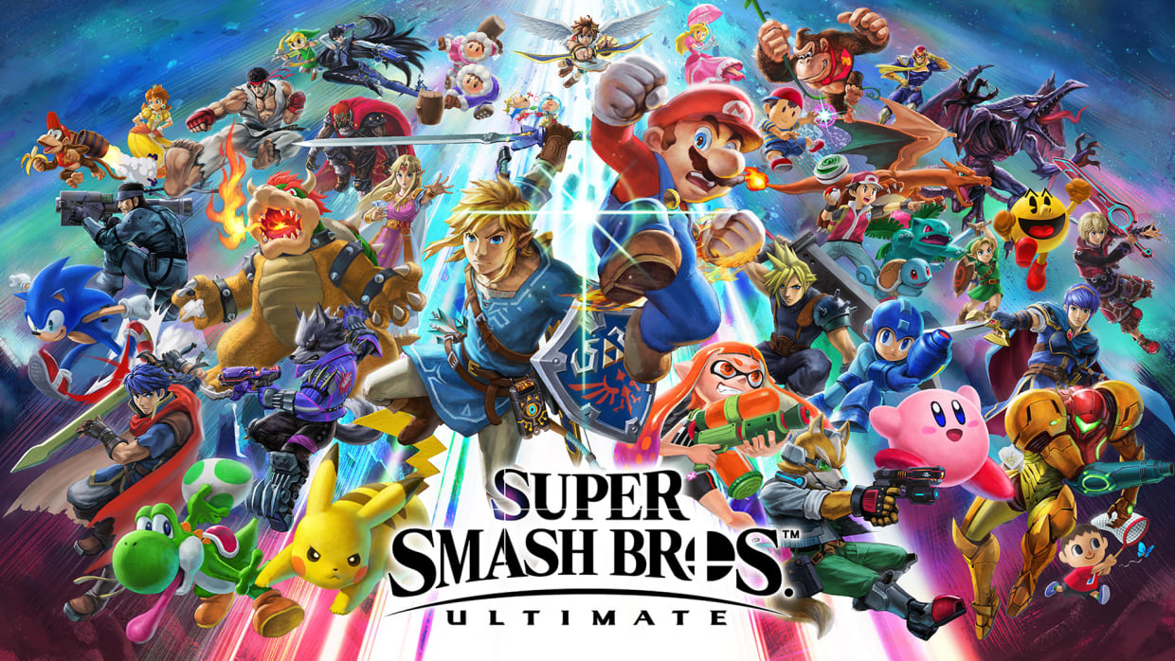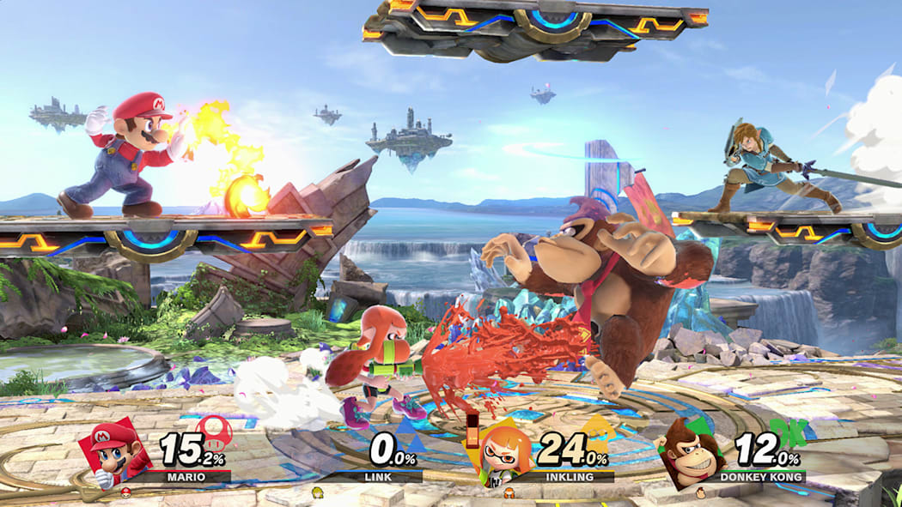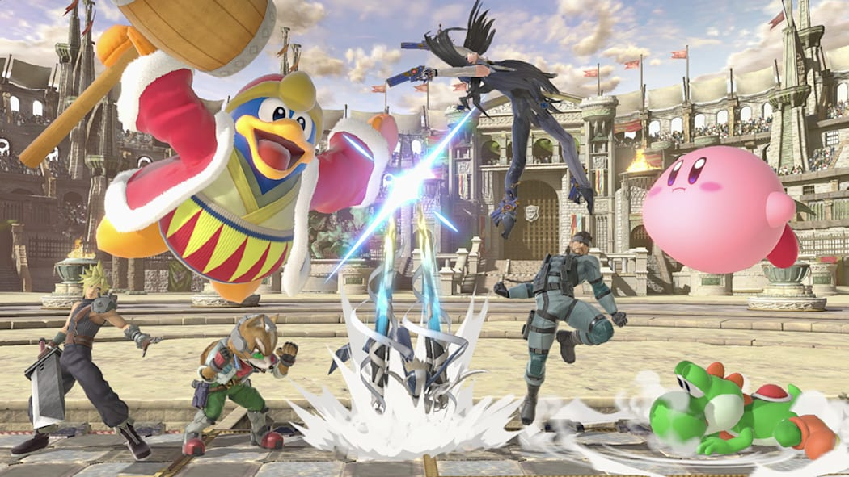

💻 System Requirements
Minimum Requirements | Recommended Requirements
Device: Nintendo Switch | Device: Nintendo Switch
Storage: 17.3 GB | Storage: 17.3 GB

