The Witcher
Experience the ultimate gaming journey!
——————————————————————————————————————

🎮 Game Information
Developer | CD PROJEKT RED
Publisher | CD PROJEKT RED
Release Date | 18 May, 2015
Genre | RPG
Platforms | PC

📝 Description
You are Geralt of Rivia, mercenary monster slayer. Before you stands a war-torn, monster-infested continent you can explore at will. Your current contract? Tracking down Ciri — the Child of Prophecy, a living weapon that can alter the shape of the world.

✨ Key Features
• Open World Exploration
• Multiplayer Mode
• Stunning Graphics

📸 Screenshots
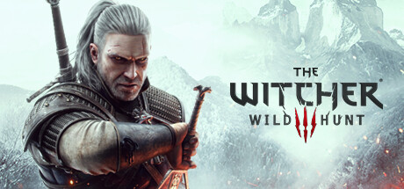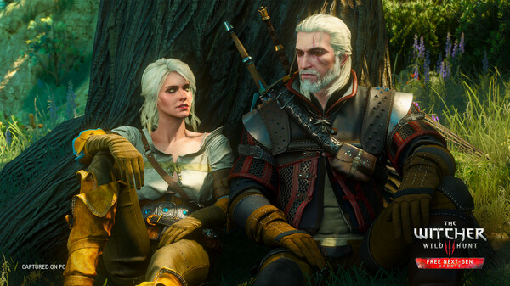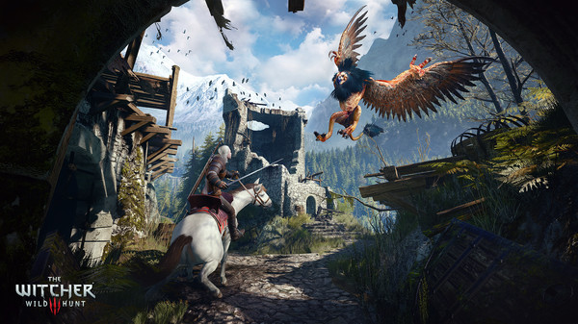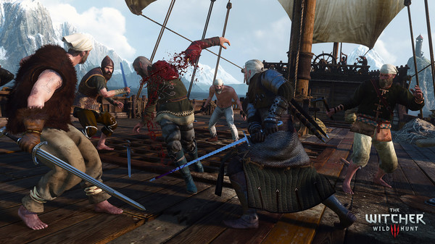

💻 System Requirements
Minimum Requirements | Recommended Requirements
Processor: Intel CPU Core i5-2500K 3.3GHz / AMD A10-5800K APU (3.8GHz) | Processor: Intel Core i5-7400 / Ryzen 5 1600
RAM: 6 GB RAM | RAM: 8 GB RAM
Graphics: Nvidia GPU GeForce GTX 660 / AMD GPU Radeon HD 7870 | Graphics: Nvidia GTX 1070 / Radeon RX 480
Storage: 50 GB available space | Storage: 50 GB available space

